Chapter 3, Problem 48.

Determine the current through the 10-kΩ resistor in the circuit in Fig. 3.93 using mesh analysis.

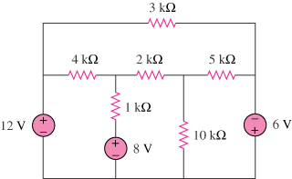
6 V
4 V
3 V

Figure 3.93
For Prob. 3.48.

